

SCHOOL OF ENGINEERING

|  |
| --- |
| Data Analytics Foundation – EN6001 |
|  |

Assignment 2

# Business Performance Dashboards

Enrollment Id Enrollment No.

Shambhavi Goswami AU19B1006

Bachelor of Technology

(2021-2022)

**Problem Statement**

Studying the provided date set and based on the data set the business requirements are required in the form of a dashboard with complete navigation.

**Sales Dashboard**

The sales dashboard comprises of 8 visualizations based on measure value: sale with Products, employees, Category , Shipper, Manager and region displayed using bar chart , bubble chart ,tree maps , density graph and text tables as shown below:

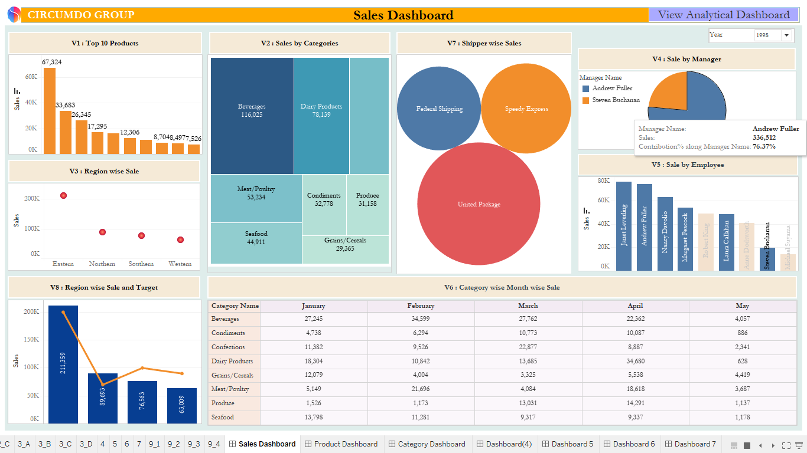

**Product Dashboard**

When clicked on Product Name in V1, user navigates to ‘Product Dashboard’ consisting of –

* 1. Ship Country wise Sale
  2. Employee wise Sale
  3. Table Consisting of Employee Name, Order Id, Potential Sale, Actual Sale, Opportunity Loss %. Add the Subtotal and Grand Total

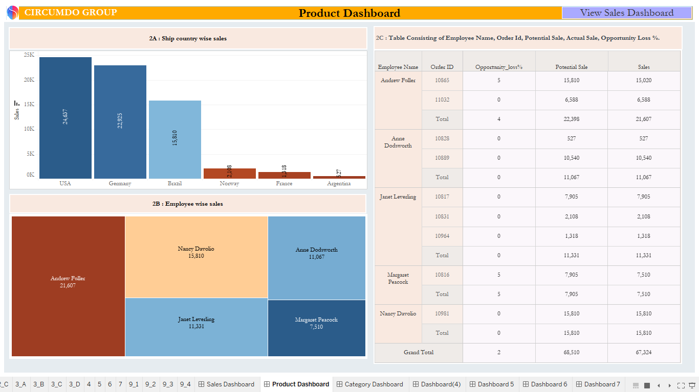

**Category Dashboard**

When clicked on Category Name in V2, user navigates to ‘Category Dashboard’ consisting of –

* 1. Top 3 Products by Sale in each Category
  2. Bottom 3 Products by Sale in each Category
  3. Top 5 Cities by Sale in each Category
  4. Top 3 Employees by Sale in each Category

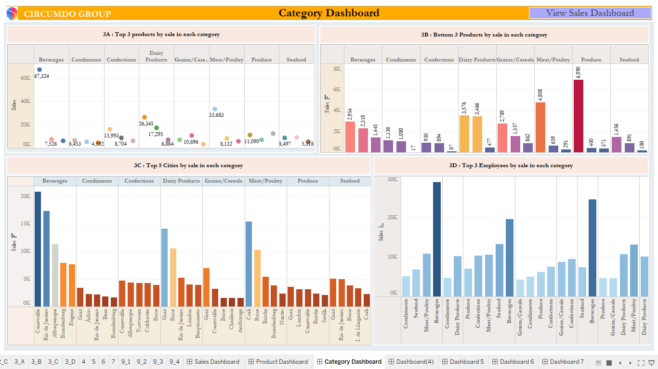

**Dashboard 4**

**When clicked on the City Name in 3.c , the Month wise trend of Sale along with 3 month moving average is displayed as follows:**

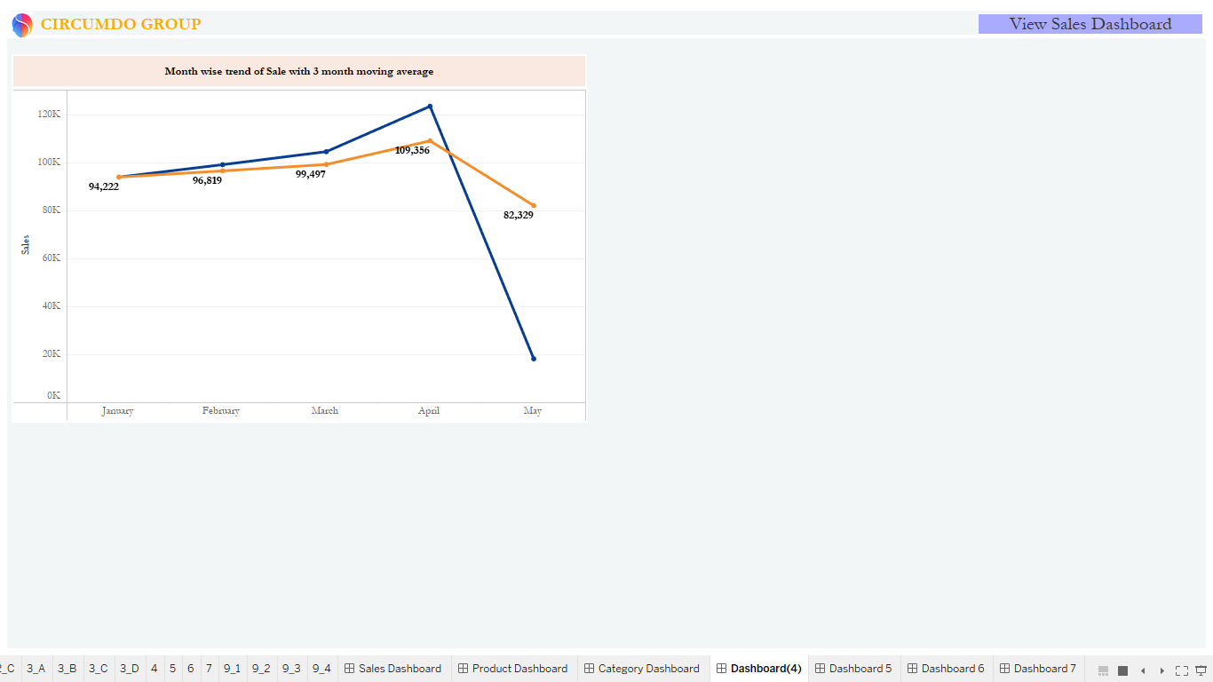

**Dashboard 5**

1. **Ship Country wise Freight is shown when clicked on V5.**
2. **When clicked on the Shipper Name in V7 then show Employee wise Freight.**

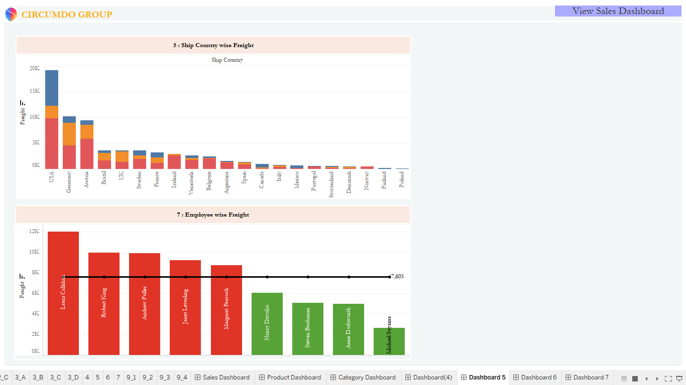

**Dashboard 6**

**When clicked on the Country Name in 5, Top N Products by Freight is displayed where N is the user input.**

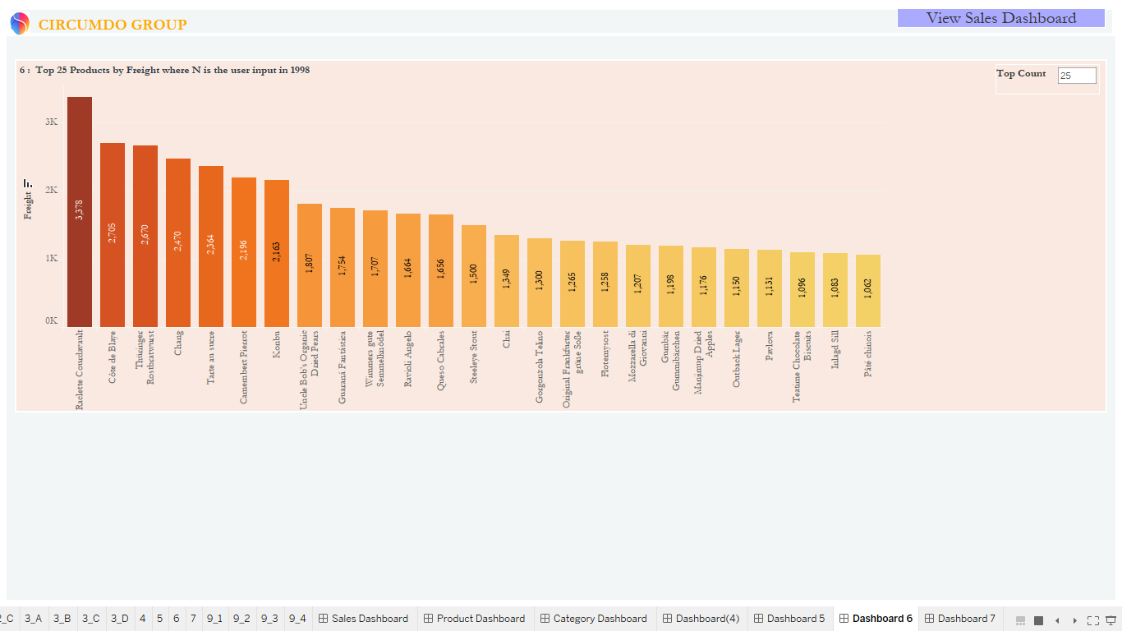

**Analytical Dashboard**

Create ‘Analytical Dashboard’ comprising of –

* 1. Category wise Sale
  2. Product wise Sale
  3. Employee wise Month wise Sale.
  4. Month wise Average Required Days per Order and Average Shipped Date per Order

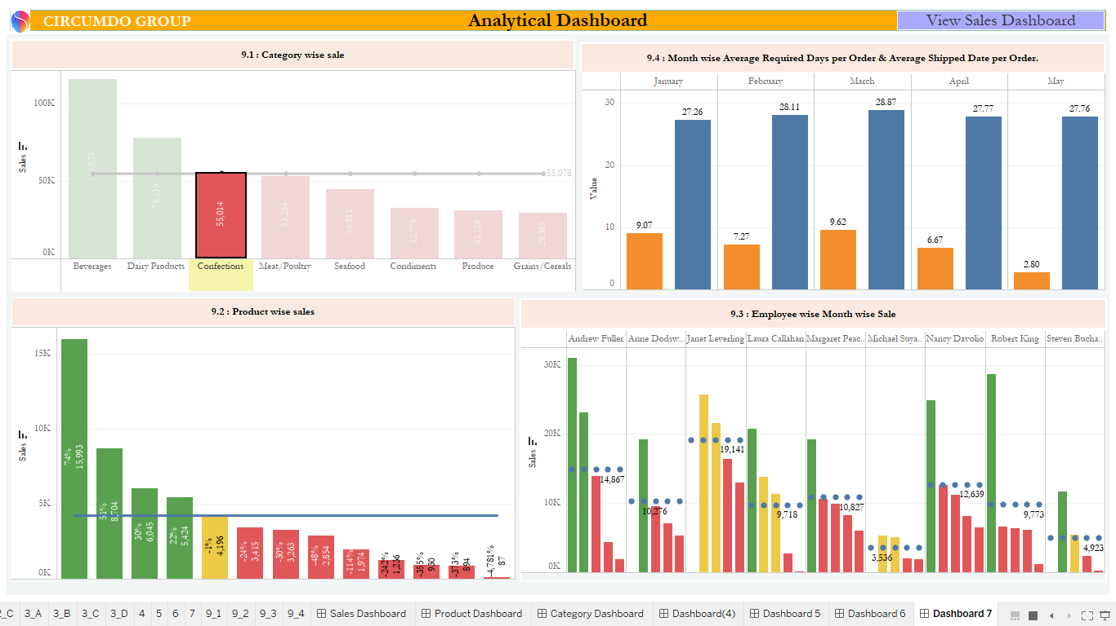

**Inference**

The report constitutes of dashboards implicating different type of visualizations. In order to fulfill the business requirements, the data source are being joined in intersection which establishes common relationships in between the intersected tables. Hence, we learn to calculate different contribution percentage of each product, category, employee and shipper for total sale and freight.

The graph represents categorization of products, region, and sales on basis of selection of different dimensions. The sales dashboard consists of 8 visualizations which are based on variation of sales which differs with selected fields. From sales dashboard, navigation is made to Product, Category and Analytical dashboards which are all filtered as per the selected year.